Graph

This example shows you how to send a byte of data from the Arduino to a personal computer and graph the result. This is called serial communication because the connection appears to both the board and the computer as a serial port, even though it may actually use a USB cable, a serial to USB and a USB to serial converter.

You can use the serial monitor of the Arduino Software (IDE) to view the sent data, or it can be read by Processing (see code below), Flash, PD, Max/MSP, etc.

Hardware Required

* Arduino Board
* Analog Sensor (potentiometer, photocell, FSR, etc.)

Software Required

* [Processing](http://www.processing.org/) or *(This software provided in course resources)*
* [Max/MSP version 5](https://cycling74.com/downloads/older/)

Circuit

Connect a potentiometer or other analog sensor to analog input 0.

[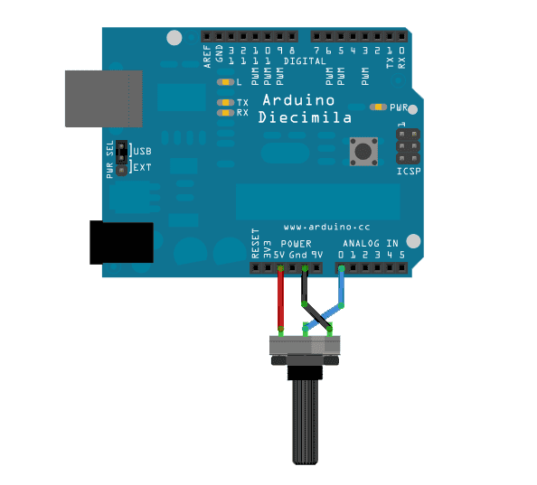](https://www.arduino.cc/en/uploads/Tutorial/graph-circuit3.png)

Schematic

[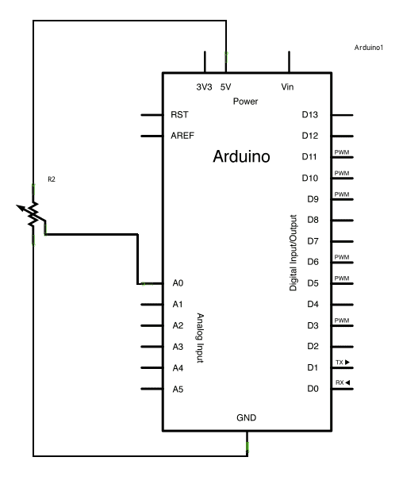](https://www.arduino.cc/en/uploads/Tutorial/AnalogReadSerial_sch.png)

Code

/*

 Graph

 A simple example of communication from the Arduino board to the computer: The value of analog input 0 is sent out the serial port. We call this "serial" communication because the connection appears to both the Arduino and the computer as a serial port, even though it may actually use a USB cable. Bytes are sent one after another (serially) from the Arduino to the computer.

 You can use the Arduino Serial Monitor to view the sent data, or it can be read by Processing, PD, Max/MSP, or any other program capable of reading data from a serial port. The Processing code below graphs the data received so you can see the value of the analog input changing over time.

*/

void setup() {

 // initialize the serial communication:

**Serial**.begin(9600);

}

void loop() {

 // send the value of analog input 0:

**Serial**.println(analogRead(A0));

 // wait a bit for the analog-to-digital converter to stabilize after the last reading:

 delay(2);

}

---------------------------------------------------------------

Processing Sketch

Using the Processing sketch in the code sample above, you'll get a graph of the sensor's value. As you change the value of the analog sensor, you'll get a graph something like this:

Note: *Close the serial monitor window to give the serial port for the Processing software*

